* Database Module 10_2
  + Charlie Group
    - Jacob Breault
    - Cameron Frison
    - Skyler Millburn
    - Angela Perkins
    - William Silknitter III

**Outland Adventures**

Business rules:

A customer can have one or more Treks. They would not be a customer without at least one trek.

Treks have one or more records in Trek_History, the number would be dependent on the number of customers on the trek.

Customers can have zero to many Orders, they don’t have to order gear, but can make multiple purchases if needed.

Employees have zero to many Employ_Trek_Hist records; Not all employees will be involved in taking customers on treks, but an employee can have multiple trek records if that is their primary job.

Inventory is a table used for keeping track of the gear, and specifically its age, as older gear could pose a hazard.

Rough/Original ORD

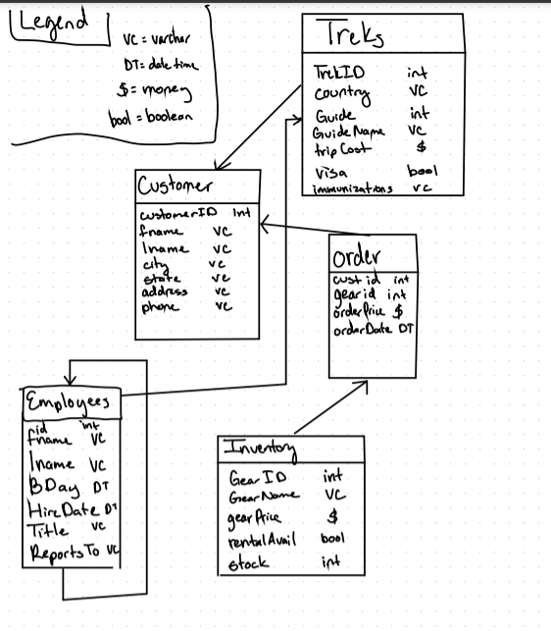

Revised ORD:

